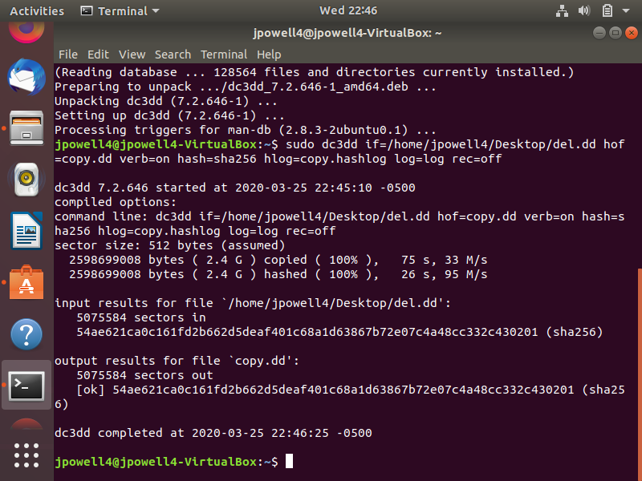
Create Forensic Copy

Mounting into gimmypigCase

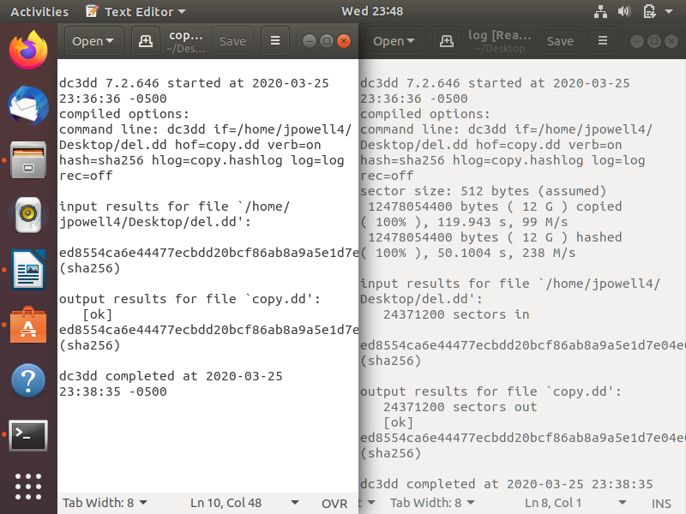
Comparing hash logs

